Protechsoft day4 notes

1. Transform
The transform property is used to change the position, size, rotation, or shape of an element.

Syntax
transform: value;

translate()
Used to move an element from its original position.

Example
transform: translate(100px, 50px);
- First value → X-axis movement
- Second value → Y-axis movement

rotate()
Used to rotate an element.

Example
transform: rotate(360deg);

scale()
Used to increase or decrease the size of an element.

Example
transform: scale(0.5);
- 1 → Original size
- 0.5 → Half size
- 2 → Double size

skew()
Used to tilt an element.

Example
transform: skew(45deg);

Questions
Q1. What is transform?
Ans: Transform is used to modify the position, size, rotation, or shape of an element.
Q2. Name some transform functions.
Ans:
- translate()
- rotate()
- scale()
- skew()

2. Animation
Animation is used to create movement and visual effects on elements.

Steps to Create Animation
- Create animation using @keyframes
- Apply animation to an element

@keyframes
Used to define animation stages.

Example
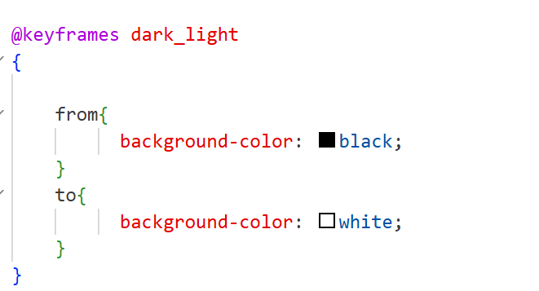

Applying Animation
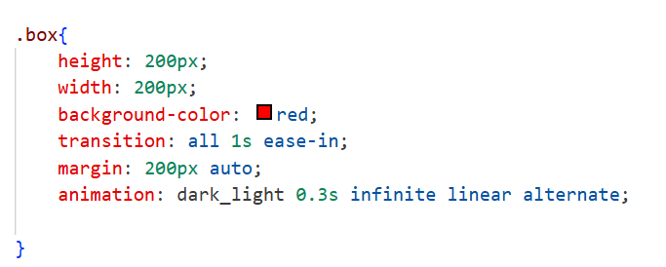

Animation Properties
Property | Purpose
animation-name | Animation name
animation-duration | Animation time
animation-delay | Delay before start
animation-iteration-count | Number of repetitions
animation-direction | Direction of animation

Questions
Q1. What is animation?
Ans: Animation is used to create movement and visual effects on web pages.
Q2. Which rule is used to create animations?
Ans: @keyframes
Q3. Which property specifies animation time?
Ans: animation-duration

3. Flexbox
Flexbox is a one-dimensional layout system used to arrange elements in rows or columns.

Why Flexbox?
- Easy alignment
- Responsive layouts
- Space distribution
- Element positioning

Display Flex
.outer{
display:flex;
}

Important Flex Properties

flex-direction

Determines the direction of items.
flex-direction: row;
flex-direction: column;

justify-content
Aligns items horizontally.
justify-content:center;
justify-content:space-between;
justify-content:space-around;

align-items
Aligns items vertically.
align-items:center;

Questions
Q1. What is Flexbox?
Ans: A one-dimensional layout model used for arranging elements.
Q2. Which property enables Flexbox?
Ans: display:flex
Q3. Which property changes flex direction?
Ans: flex-direction
Q4. Which property aligns items horizontally?
Ans: justify-content
Q5. Which property aligns items vertically?
Ans: align-items

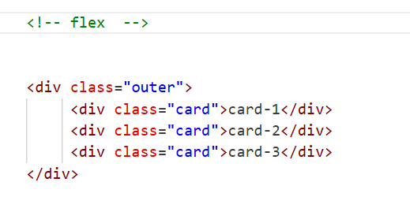
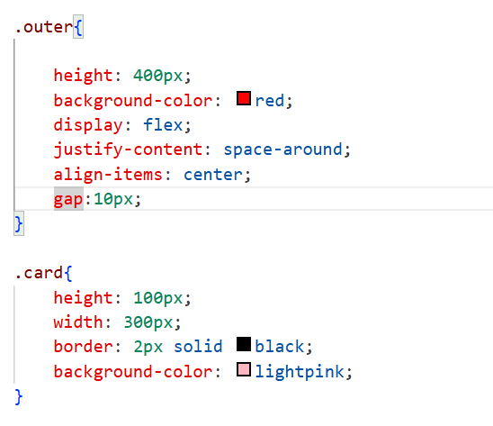
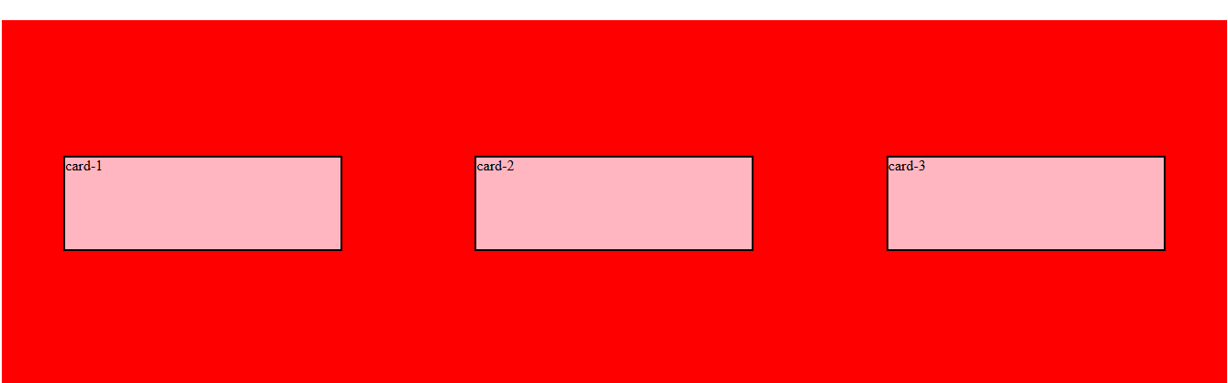

4. Responsive Web Design
Responsive design makes webpages adjust automatically to different screen sizes.

Benefits
- Mobile Friendly
- Better User Experience
- Works on all devices

5. Media Query
Media queries are used to apply styles based on screen size.

Syntax
@media(condition){

}

Example
@media(max-width:798px){

h2{
color:green;
}

.outer{
background-color:yellow;
flex-direction:column;
}
}

Explanation
When screen width becomes 798px or less:
- Heading color becomes green.
- Flex direction changes to column.
- Background color changes to yellow.

Questions
Q1. What is Responsive Web Design?
Ans: Designing webpages that work properly on different screen sizes.
Q2. What is a Media Query?
Ans: A CSS feature used to apply styles based on device size.
Q3. Which rule is used for responsive design?
Ans: @media
Q4. What does max-width mean?
Ans: Styles will apply when screen width is equal to or less than the specified value.

